Create a React Application named “cricketapp” with the following components:

1. ListofPlayers
   * Declare an array with 11 players and store details of their names and scores using the map feature of ES6

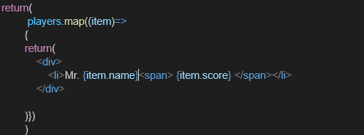

* + Filter the players with scores below 70 using arrow functions of ES6.

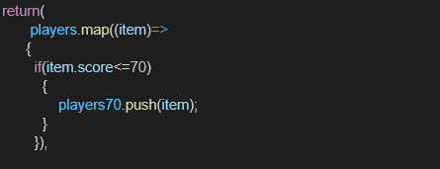

# ListOfPlayers.js

import React from 'react';

function ListofPlayers() { const flag = true;

const players = [

{ name: "Jack", score: 50 },

{ name: "Michael", score: 70 },

{ name: "John", score: 40 },

{ name: "Ann", score: 61 },

{ name: "Elisabeth", score: 61 },

{ name: "Sachin", score: 95 },

{ name: "Dhoni", score: 100 },

{ name: "Virat", score: 84 },

{ name: "Jadeja", score: 64 },

{ name: "Raina", score: 75 },

{ name: "Rohit", score: 80 }

];

const playersBelow70 = players.filter(player => player.score <= 70);

return (

<div>

{flag && (

<>

<h2>List of Players</h2>

<ul>

{players.map((item, index) => (

<li key={index}>

Mr. {item.name} <span>{item.score}</span>

</li>

))}

</ul>

<h2>List of Players having Scores Less than 70</h2>

<ul>

{playersBelow70.map((item, index) => (

<li key={index}>

Mr. {item.name} <span>{item.score}</span>

</li>

))}

</ul>

</>

)}

</div>

);

}

export default ListofPlayers;

# App.js

import React from 'react'; import './App.css';

import ListofPlayers from './ListofPlayers';

function App() { return (

<div className="App">

<h1>Welcome to Cricket App</h1>

<ListofPlayers />

</div>

);

}

export default App;

